Junior Golf
Applications Accepted April 6th
@ 8 AM in the Pro Shop
Applications will not be accepted before 8 AM April 6th.
This is a first come first served basis.

Elks 1187 Golf Course
3333 Jolly Lane
Rapid City, SD 57703
Ph # 393-0522 Ext 3

2024 ELKS GOLF COURSE SUMMER JUNIOR GOLF INSTRUCTION

- 8 Hours of instruction from June 3rd to June 25th
- Open to boys and girls, of all abilities, ages 6-15
- Classes for ages: 6 - 8, 9-11, and 12-15
- All Students will receive a free Junior Season Pass for the summer included in the price. $230 value!

Cost: $150 plus tax ($159.75 tax included)

The Elks Junior Golf Program focuses on having fun and teaching all the aspects involved in becoming a complete golfer. Topics that will be covered are: Etiquette, Safety, Rules, Practice Skills, Tournament Procedures, Course Management, and the Five Fundamentals. The Skills that will be taught are putting, chipping, pitching, bunker play, and the swing from wedge to driver.
One of the goals of the Elks Junior Golf Program is to provide our juniors the opportunity to improve their skill and knowledge of the game, each year that they return. To help achieve this goal we offer education to juniors whether beginner, intermediate or advanced.
Our program is fun, educational and will fill up fast. Come join us!!!

To sign up please stop out at the Elks Golf Course at 3333 Jolly Lane.

APPLICATION

APPLICATIONS WILL BE ACCEPTED AT THE ELKS GOLF SHOP ONLY. MAKE CHECK PAYABLE TO Elks Golf Course.

* COST $159.75

NAME: _________________________________________

ADDRESS:____________________________________________________________

CITY/STATE: ____________________________________

PHONE#:_______________________________________

BIRTH DATE: _______________AGE ON 6/1/24______

PARENT/GUARDIAN NAME: ______________________
HOME PH#_______________

ADDRESS: ______________________________________

WORK PH#:___________________

CITY/STATE: ____________________________________

ZIP: _______________

ANY ADDITIONAL INFORMATION_________________________________

T-Shirt Size Youth Sm, Med, Lg, XL
Adult Sm, Med, Lg, XL

Class Times Schedule

Ages 6-8 9:00-10:00
Ages 9-11 10:15-11:15
Ages 12-15 11:30-12:30

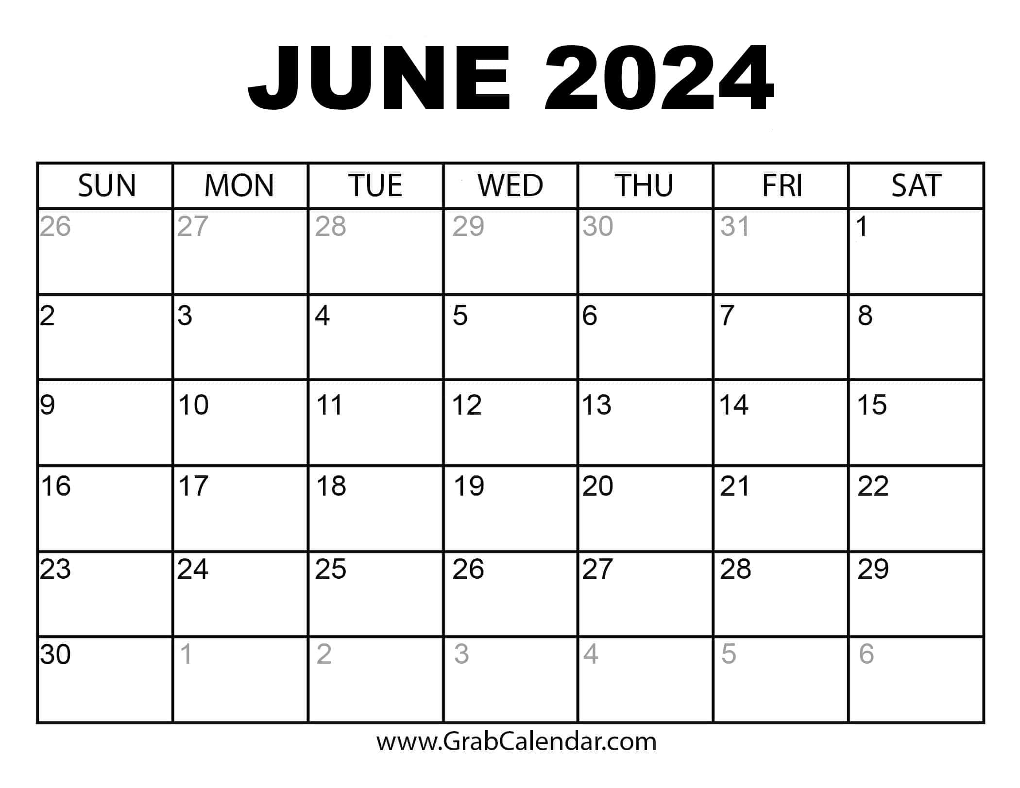
Junior Golf
Junior Golf
Junior Golf
Junior Golf
Junior Golf
Junior Golf
Junior Golf
Junior Golf

